Dear Student!!
For this, firstly on the tool box, go to Preferences
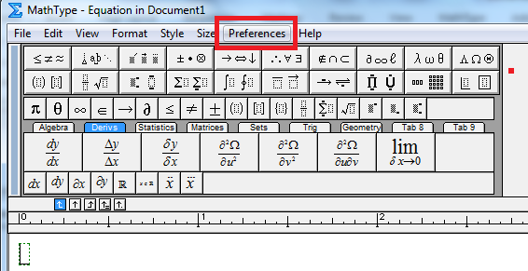
Then click on Cut and Copy Preferences,
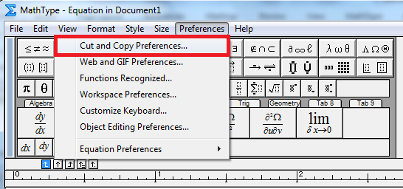
Then CHECK on Equation Object, and then OK.
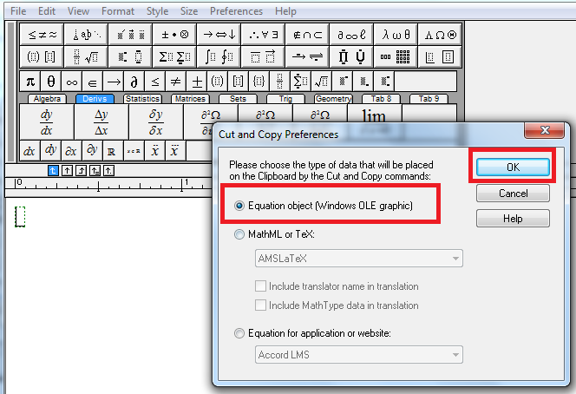
Hope after this you would be able properly to paste the readable math expressions without coding objects.

